Capstone Design Final Report

기계공학과

20150027 강지원

Capstone Design Progress report (3/19~3/25)

20150027 강지원

오준호 교수님

1. Overall Progress

On March 19th, we discussed the mechanism of picking up and dropping off the ball with professor oh. We proposed five ideas, valve, horizontal roller, vertical roller, cage and sweeping. Professor advised us to hurry up with finalizing our concept and focusing more on details about each part such as gears and component arrangements.

We compared each concept with Pugh’s method and chose cage and valve as our final concept of picking mechanism emphasizing on accuracy, creativity and efficiency. In order to test whether our plan would work as our imagination, we conducted an experiment. We bought thick fishing line, thin fishing line and thread and a box with holes. We made a prototype for each material and made a variation with the distance between the lines and tested whether the ball would go inside the box easily. However the problem was that if the ball was off the center then the ball would not go inside easily.

For the solution we decided to add a motor to control the length of the wire.

2. ROS part

We had a lecture by 표윤석 about the basic concept of ROS. We also had a TA session about Ubuntu and fundamental skills about managing ROS.

ROS team worked with assignments about making packages and publisher and subscriber nodes, service server and client nodes. We learned how to send messages from node to node specifically for topic and service. We also learned skills such as ROS launcher, atom.

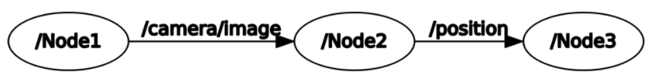

Capstone Design Progress report (3/26~4/1)

20150027 강지원

오준호 교수님

1. Overall Progress

Our basic design concept and solidworks design have been finalized. We also discussed about how to move the picking box up and down. We came up with chains, worm gears and rack and pinion. However we chose linear guide and ball screw which our TA recommended. We also discussed the position of the motors which control the length of the wires and also decided to use two webcams to detect the ball more accurately.

In order to prepare for the first presentation we divided our presentation into parts and made ppt and script. I made ROS and vibration damping part.

Me and Jungsoo prepared for the speech and covered up the first half part explaining problem and system how we solved our problem and basic mechanisms for picking up and dropping the balls.

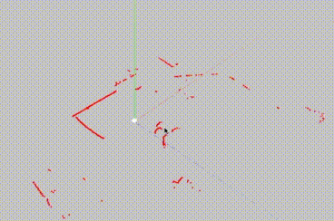2. ROS part

We had TA session about how to deal with data from webcam and rplidar. We learned how to use rviz to visualize informations and also defining coordinates of our robot.

We also learned how to use xbox to test our robot.

Our plan is to draw an overall integration map for every components of our system.

Capstone Design Progress report (4/2~4/8)

20150027 강지원

오준호 교수님

1. Overall Progress

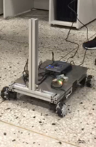For overall progress we made our car body with aluminum profile and attached dynamixels and wheels. The job for labview part is almost over and only minor details. So by using ROS xbox control code we tested our robot moving and checked that our prototype moves well.

And for some feedbacks we got, we had to consider the conditions of the floor in the mechanical building because the prototype couldn’t move accurately on slippery floors. We should check the errors that come from floor changes. Also we had to buy some materials such as gearbox, webcam, linear guide and etc.

2. ROS part

We set our goal for 2nd presentation for ROS to make maps from rplidar information and get the robots position data, and also get the code from opencv and finally integrate the information from two. First we tried to make maps. We found two packages and checked both and got some programming problems and we are trying to solve the problem.

Capstone Design Progress report (4/9-4/15)

20150027 강지원

오준호 교수님

1. Overall Progress

For overall progress we had group meeting and talked with TA about converter problem. We first thought that we needed 10A for motors considering stall currents. So we first thought to buy 19V converter for nuc and 12V 10A for motors. TA advised us to not use converter for nuc and buy 12V 10A converter for motors. Also TA advised us to check aluminum profile with other thicknesses for picking up part because it will be lighter if we use thinner aluminum profile.

With our midterm exam, we decided to focus on midterm exam for this week.

2. ROS

We tried another package for mapping with rplidar and couldn’t solve the problem of getting map datas. We also had problem with storage of our laptops so we decided to use nuc with teamviewer.

We will have to solve the mapping problem and also how to use codes from opencv.

Capstone Design Progress report (4/16-4/22)

20150027 강지원

오준호 교수님

1. Overall Progress

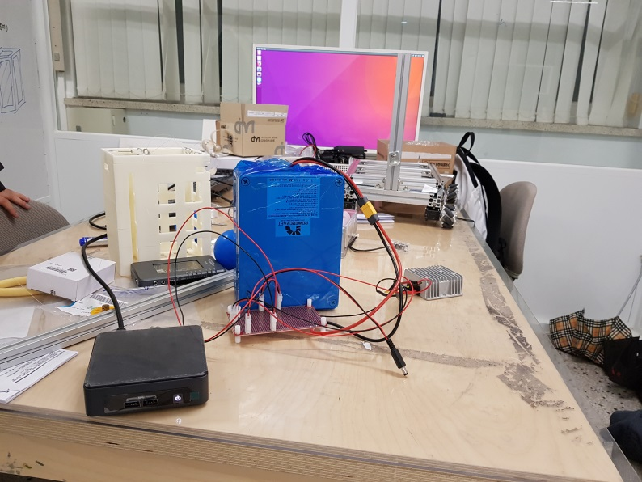After our midterm exam we had soldering session assisted by our team TA. We bought a DC-DC converter which changes 24V into 12V. For our team, battery emits volts of 21.4V and nuc requires 19V, myRio 6 to 16V, and dynamixel requires 12V. We used connectors and now we are able to connect every components of our robot.

2. ROS part

After midterm exam we had a ROS TA session on Friday. It was time for asking questions, and we were curious about using slam and gmapping. We were unable to use packages to our program and TA advised to just not use gmapping because it would be too hard for us and also too busy considering our schedule. TA told us to just focus on drawing the whole map of our program.

Capstone Design Progress report (4/23~4/29)

20150027 강지원

오준호 교수님

1. Overall Progress

Until our second presentation we decided our goal to detect closest ball and get to the ball without considering obstacles such as red balls. For the hardware of our robot we made a prototype which holds every component such as nuc and battery. For opencv we changed our code from TA code. For ros we made code which detects closest ball and gets close to the ball and it worked on our robot.

2. ROS part

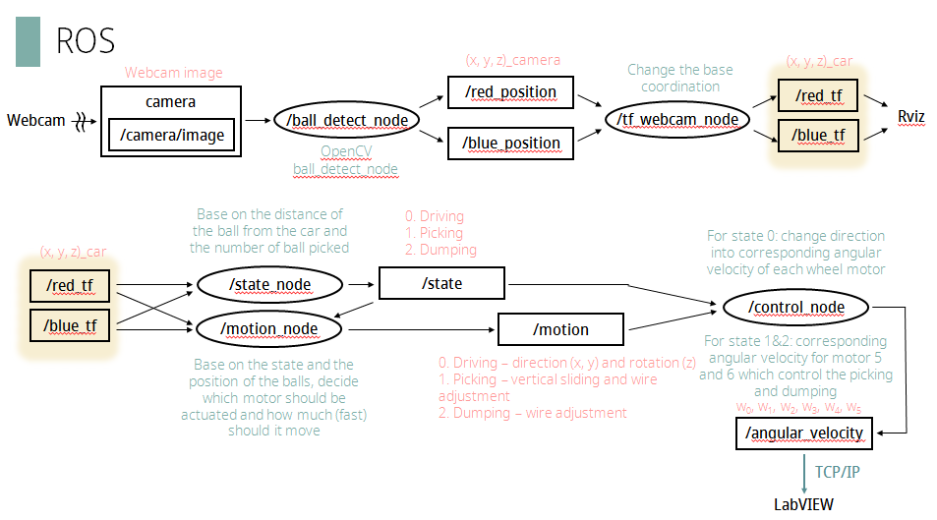

For ros we first planned not to use mapping so we drew a map containing every nodes and messages. Because we have picking part, the difference with other teams is that we devided our movements of our robot in three parts, getting close to the ball, picking up the ball, dropping the ball. For our second presentation we succeeded in making the robot to detect the closest blue ball and getting close to the ball. For our future plan we should consider picking and dropping the balls and also considering red balls.

Capstone Design Progress report (4/30-5/6)

20150027 강지원

오준호 교수님

1. Overall Progress

We had a presentation on this Friday. We presented about what we have done since our first presentation. We finished two among three big tasks this week. First we had succeeded in tracking the nearest blue ball and getting close to it. Second we succeeded in picking up the ball only using xbox controller. From now on we should attach second webcam and think about the most effective way to arrange the positions of our parts. We also have to manage vibration damping and heat control.

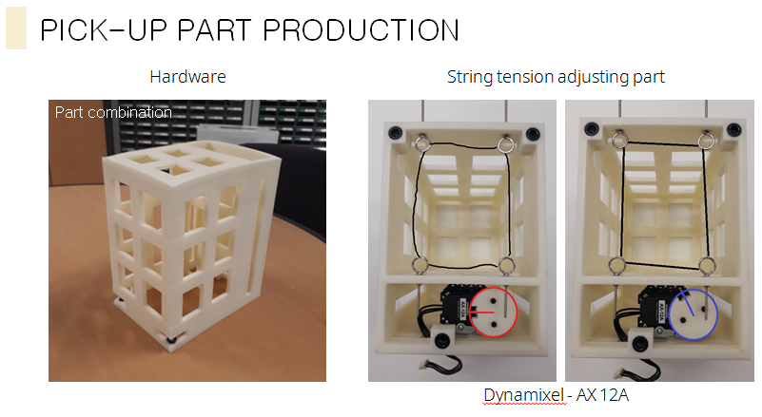

1. ROS part

We succeeded in making code for tracking the nearest ball and getting close to it. From now on we should add code for picking up part and avoiding walls and red balls. We also have to add code for tracking back to the basket. We also have to manage places for two webcams and calculate exact positions for each webcam.

Capstone Design Progress report (5/7-5/13)

20150027 강지원

오준호 교수님

1. Overall Progress

After our second presentation, we got feedback to add detail explanation for heat management and vibration damping. We thought of adding sensors to detect temperature change and controlling the energy use in our motors. We also bought new mechanum wheels much bigger than the older one and we are expecting that we won’t need to consider avoiding red balls because it will just pass by.

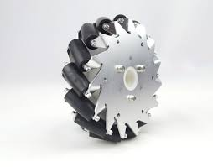

1. ROS part

We have done making code for each picking up and tracking the nearest blue ball. So from now on we have to integrate code and make the robot to adjust to every situations.

We also have to calculate exact locations for two webcams.

Capstone Design Progress report (5/14-5/20)

20150027 강지원

오준호 교수님

1. Overall Progress

For overall progress we attached bigger mecanum wheels and adjusted picking up part. For vibration problem we conducted an experiment. While running our machine we got acceleration data from myrio and through fourier series expansion we finalized frequency that affects the vibration the most. Surprisingly it was almost equal to the frequency we calculated from mecanum being different with perfect circle. For heat management we did soldering to make circuits for the fans by using the transistors and found a problem of transistor being too hot.

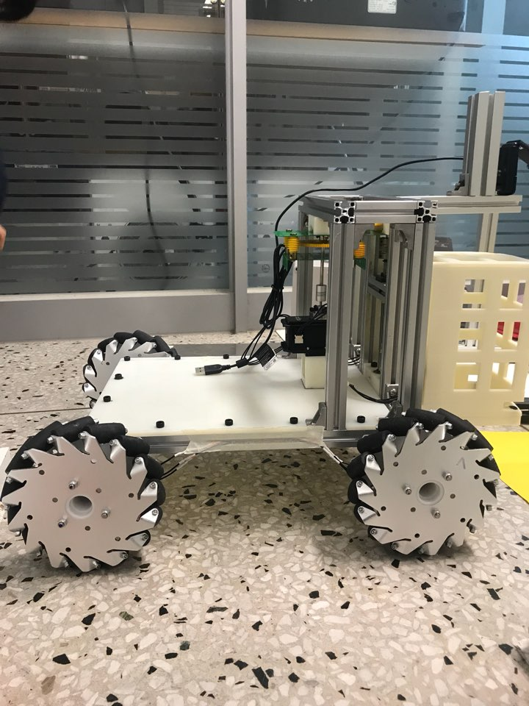

2. ROS

We almost finalized our hardware part, so we had to finalize the transformation and control values for ros code. We measured several length values and angle values of our robot and made exact transform values. In our demonstration time we found a problem that because the robot cannot detect the exact position of ball the picking up part stuck little bit so we loosened our picking part.

Capstone Design Progress report (5/21-5/27)

20150027 강지원

오준호 교수님

1. Overall Progress

For overall progress we almost finalized the positions of our components. We also enhanced our picking up part more accurately. We also fixed the angles of our webcams and increased the height of our robot by putting extra piece between our mecanum wheels and body. For vibration management we haven’t decided exact solution but made an appointment with vibration professor. On the other hand for heat management we changed the transistor into mosfet because of excessive heat from transistors. We also conducted soldering to make circuits for thermistors. We are planning to turn on the fan only when the temperature of certain parts of our robot is heated above certain temperature.

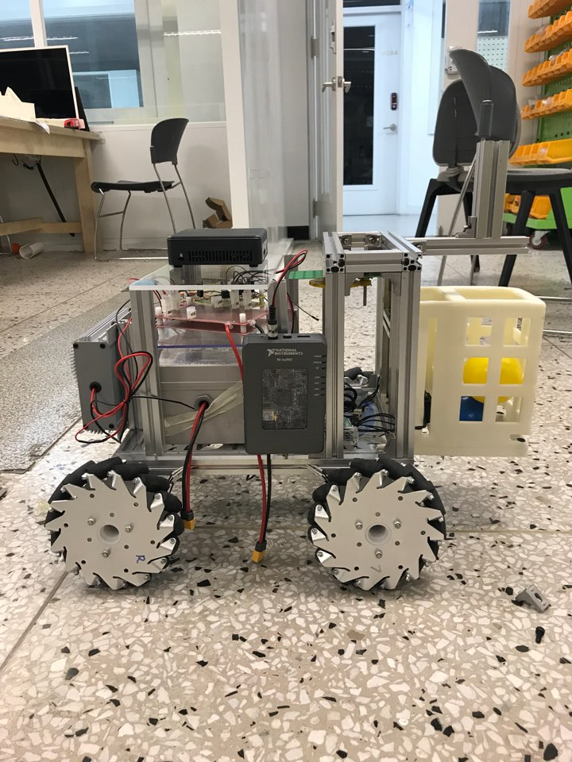

2. ROS

For ros part we are planning to not avoid the red balls to decrease time required. We adjusted the parameters in transformation and control code and checked in our demonstration time and it couldn’t pick up the balls sometimes. We are also planning to use rplidar when we approach to the green balls to drop off the balls.

Capstone Design Progress report (5/28-6/3)

20150027 강지원

오준호 교수님

1. Overall Progress

For our final presentation we had to finalize our hardware first. We made 3 layers to put our components and attached thermistors to each component. We also attached 4 fans close to the heat source which are battery and myrio. We only operate our fans when the temperature passes certain limits for each component. We also tried to analyze heat management with potential flow along our component, however it wasn’t applicable to the real world. For vibration damping, we used vibration absorber method. Our unique characteristic is that we don’t use outer material but our own component, battery as our absorber.

2. ROS

For software ros part, we had to finalize our path generation. We first had to change parameters that calculate distances to the blue balls. We conducted several experiments to match the parameters. Our teams unique characteristic for ros code is that we don’t care about red balls but just ignore it. Our method is possible because we have larger mecanum wheels. We just follow to the closest blue ball but we have other positive aspects. We are the only team to have both rotation and transition at the same time and we only added codes for some minor cases that red balls might block blue balls for the second webcam. We also added lead assistance at the bottom of our picking up part to prevent the balls from stucking under our pick up part.